

# Start Screen

# 

# Game over Screen

CHARACTERS-

1. MAIN CHARACTER- A scientist working for the government on the cure for an incurable disease. He is living on a remote island to stay protected. Wields a laser-gun that runs on light so the ammo never runs out.
2. MAIN VILLAIN- A tech multi-millionaire who(coincidently), suffers from the same disease the hero is researching on. The villain has developed the technology required for inter-portal transport instantly.
3. HENCHMEN OF THE VILLAIN- Robots that the villain develops to aid him. They are very rudimentary and were originally made for basic work.

STORY-

The hero, while perfecting the antidote for the incurable disease in his lab, hears a loud sound. When he goes to examine it, he sees a group of robots coming towards him. He gets his guns and goes to attack them.

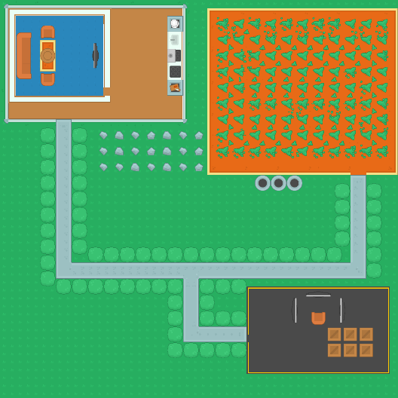***LEVEL 1-HOME BASE***

The last robot escapes through a portal and the hero tries to follow him but ends up on a desert land. Robots there try to stop him.

***LEVEL 2-DESERT***

Trying to escape from the hero, the remaining robots flee through a portal again, and the hero continues his chase to regain the antidote. This time he ends up inside a cave. He lights up a flash machine that provides light. There he encounters more robots.

***LEVEL 3-CAVE***

With the last robot left, the hero continues the pursuit to regain the antidote, and this time he ends up in a building that seems to be an office of some kind. Large amounts of robots attack him.

***LEVEL 4-BOSS BUILDING***

Somehow the hero survives the swarm and sees one robot take the antidote through the door, so he goes through that door. There he encounters the main villain, who attacks him.

***LEVEL 5-FINAL BOSS***

After defeating the main villain, the main villain reveals that the only reason he wanted the antidote is that he wanted to cure millions suffering from the incurable disease at no cost. When the hero says that that’s what the government is trying to do, the villain chuckles and says that at the government’s rate, many will die before the cure is available, and the government will have no answers. This puts the hero in a dilemma (the player is given a choice here to-

1. either hand over the antidote, or
2. reject the offer and force the villain to send him back home

IF CHOICE IS 1-

Hero decides to hand over the antidote, but as soon as he hands over the antidote, the villain screams “FOOL!” and opens a portal and jumps through it. The hero is knocked out. WRONG CHOICE

THE END

IF CHOICE IS 2-

The villain tries one final attack, this time by himself that the hero fails and opens a portal home. RIGHT CHOICE

THE END